SIMATS ENGINEERING
Department of Computer Science and Engineering
ASSESSMENT TOOL 1– Concept Mapping

Course Code: CSA0312 Course Title: Data Structures
CO Assessed: CO1 – Imitation (BL3, BL4) Assessment: Assessment Tool 1 – Concept

Mapping
Weightage: 10% of CIA Total Marks: 100

CO1 Statement:

Basics, Data, Data object, Data structure, Abstract Data Types (ADT), realization of ADT in ‘C’,
Primitive and non-primitive data structure, Linear and non-linear data structure Arrays &amp; Recursion,
Performance analysis and Measurement: Time and space analysis of algorithms, Average, best and
worst-case analysis.

Student Name: Reg. No.: Shaik mahamad Sohail (192511120)
Section / Batch: Date: 24/07/2026

1.A music streaming application manages playlists where songs are added, removed, and played sequentially. Construct a concept map linking Array → Linked List → Stack → Queue → Operations (Insert/Delete/Traverse). Explain how each structure can be applied in playlist management and justify the most suitable structure based on performance and flexibility.

A music streaming application stores and manages playlists using different data structures. Each structure has its own advantages for adding, removing, and playing songs.
- Array: Stores songs in contiguous memory. It allows fast access using an index but inserting or deleting songs in the middle requires shifting elements, making it less efficient.
- Linked List: Stores songs as connected nodes. Songs can be inserted or removed easily at any position without shifting other elements, making it highly flexible for playlist management.
- Stack: Follows the Last In, First Out (LIFO) principle. It can be used to maintain the Recently Played songs so users can return to the previous song.
- Queue: Follows the First In, First Out (FIFO) principle. It is useful for managing the Up Next playlist where songs are played in the order they were added.
- Operations:
  - Insert: Add a new song to the playlist.
  - Delete: Remove a song from the playlist.
  - Traverse: Play or display all songs sequentially.
Justification
Among these data structures, the Linked List is the most suitable for playlist management because it supports efficient insertion and deletion of songs at any position without moving other elements. It also provides better flexibility for dynamic playlists where songs are frequently added, removed, or reordered.

OPERATIONS:
Operation | Array | Linked List | Stack | Queue
Insert | Fast at end, slow in middle | Efficient | Push | Enqueue
Delete | Slow in middle | Efficient | Pop | Dequeue
Traverse | Easy | Easy | Top to Bottom | Front to Rear
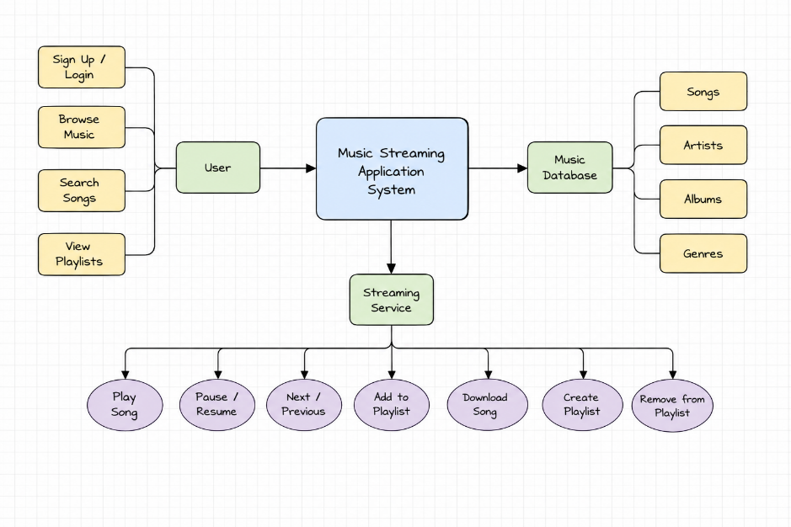
Conlusion:
A practical music streaming application primarily uses a Linked List to store the playlist, while a Stack manages playback history and a Queue handles upcoming songs. This combination provides efficient insertion, deletion, traversal, and overall flexibility.
2. A student attendance system records daily presence data. Construct a concept map linking Array →Fixed Size → Sequential Access → Linked List → Dynamic Allocation → Flexibility. Explain how each structure works and justify which is more suitable for dynamic data updates.

Student Attendance System using Array and Linked List
A student attendance system stores the daily attendance status (Present/Absent) of students. The choice of data structure affects how efficiently records can be stored, accessed, and updated. Arrays and Linked Lists are two commonly used data structures for this purpose.
Explanation of Each Structure
1. Array
- An array stores attendance records in contiguous memory locations.
- It has a fixed size, which is decided when the array is created.
- Attendance records can be accessed quickly using their index (sequential access).
- Insertion or deletion of records is difficult because existing elements may need to be shifted.
2. Fixed Size
- The number of elements is predetermined.
- If the number of students increases beyond the array size, a new array must be created.
3. Sequential Access
- Records are stored one after another.
- Each student's attendance can be accessed directly using its index, making retrieval fast.
4. Linked List
- A linked list stores attendance records as nodes connected through pointers.
- Memory is allocated dynamically during program execution.
- New records can be inserted or deleted easily without shifting other records.
5. Dynamic Allocation
- Memory is allocated only when needed.
- The data structure can grow or shrink according to the number of attendance records.
6. Flexibility
- Linked lists provide greater flexibility because they support easy insertion, deletion, and modification of records.
- They are well suited for applications where the number of records changes frequently.
Justification
For a student attendance system with frequent additions, deletions, or updates, a Linked List is more suitable because it uses dynamic memory allocation and allows efficient insertion and deletion without shifting elements. An Array is suitable when the number of students is fixed and fast indexing is required. Therefore, Linked List is the better choice for dynamic data updates due to its flexibility and efficient memory management.

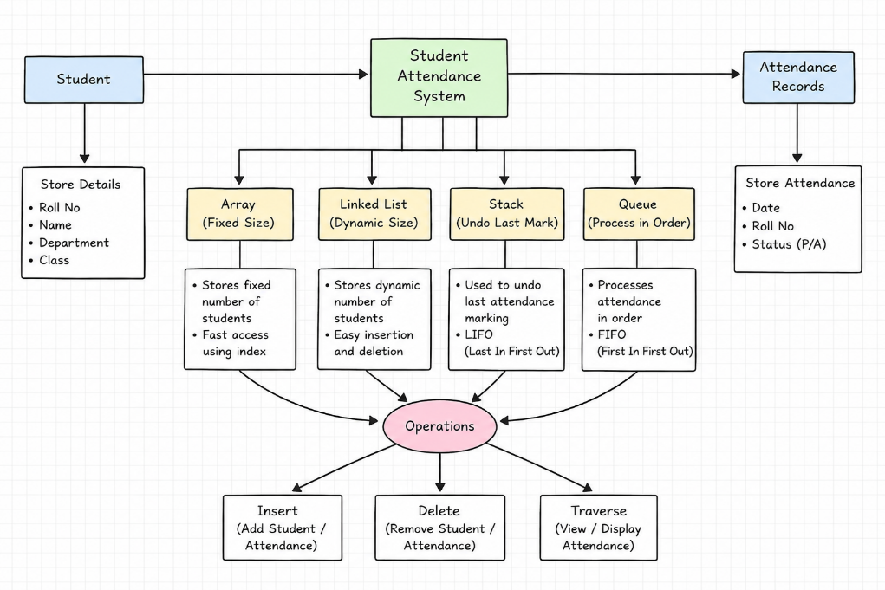

Conclusion
Arrays and Linked Lists are both useful for managing student attendance records. Arrays provide fast and simple access to data but have a fixed size and are less efficient for frequent updates. Linked Lists use dynamic memory allocation, making it easy to add, delete, and modify attendance records.

